חלופה מערכות הגנת סייבר במקצוע "תכנון ותכנות מערכות" - הערכה לעבודת גמר 5) יחידות לימוד( – תשפ"ה

341105369 | מספר ת.ז. | גאורגי | שם התלמיד
Blockchain wallet |  |  | נושא העבודה

Revision History

Ed. Id | Date | File Reference | Reason for Change
1 |  |  | Baseline

Introduction
Define any important terms, acronyms, or abbreviations
Blockchain - Blockchain is a decentralized digital ledger that records transactions across multiple computers in a secure and transparent way. Each transaction, or "block," is linked to the previous one, forming a chain. This ensures that once data is added, it cannot be altered or deleted without changing all subsequent blocks, which requires consensus from the network.

System Overview
The project is like a crypto wallet working on a blockchain across multiple computers.
There are miners who make the network work, aclients and a node that acts like hub to redistribute messages between all members of the network.

Related software or hardware
The project is windows based

End-user characteristics
The target audience is people who want a trustable way to store their money in a decentralized environment.

General Constraints
The follow constraints are implemented in the project:
- Data repository: github
- No specific requirements for memory
- Programming Language: python
- Encryption: private public key, hash
- Network Protocol: tcp, socks5
- Database protocol: sqlite3

System Architecture - Functionality

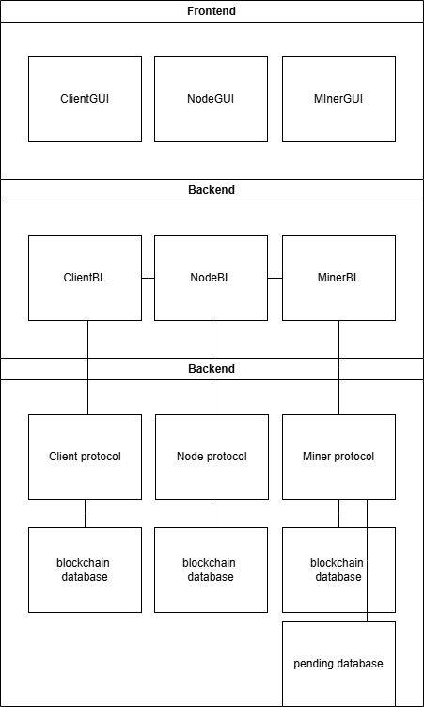

Subsystem Architecture

Use Case – 1st…

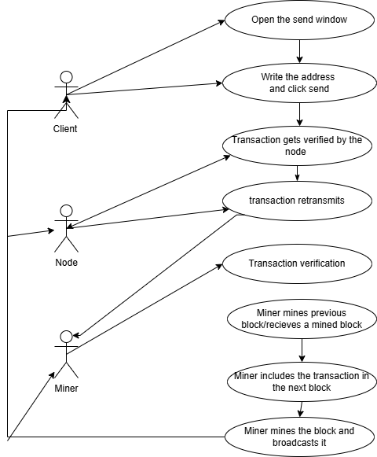

Use Case – 2nd…

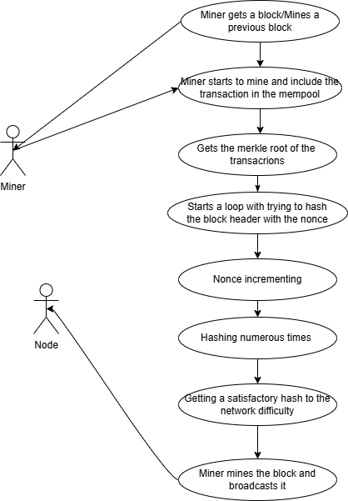

Sequence diagram – 1st…
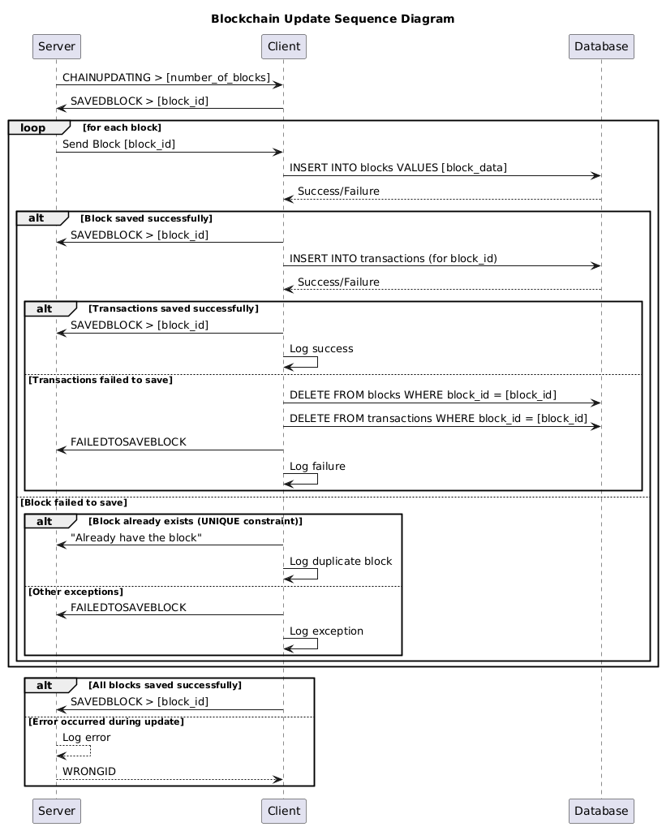

Sequence diagram – 2nd…
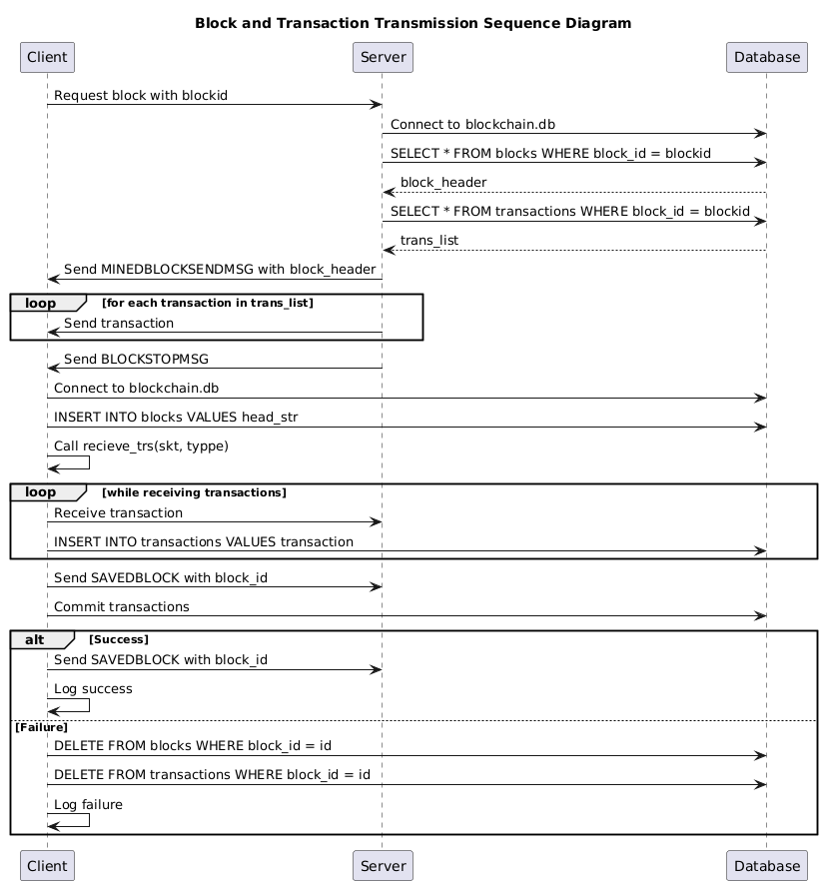
…

DB tables
…
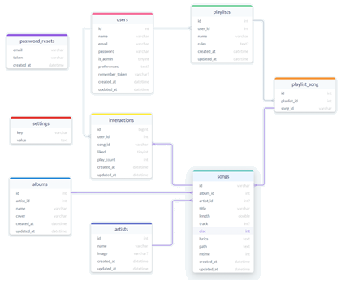

Protocol
…
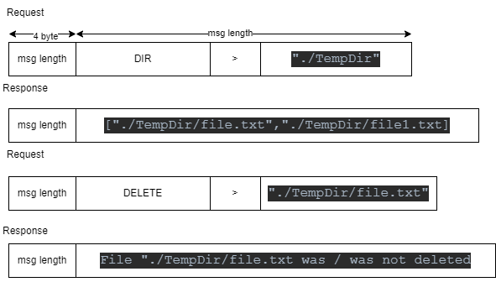

Encription
…

Classes
…
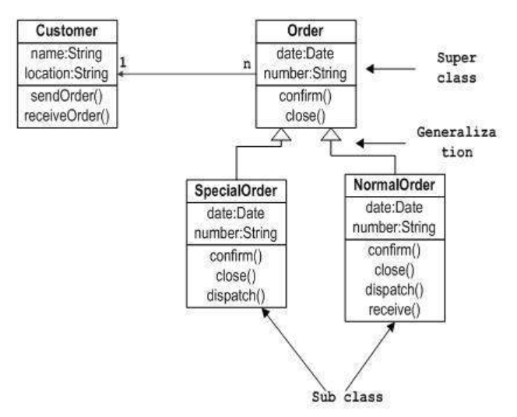…

System Architecture - Presentation Layer
…

Forms workflow
…
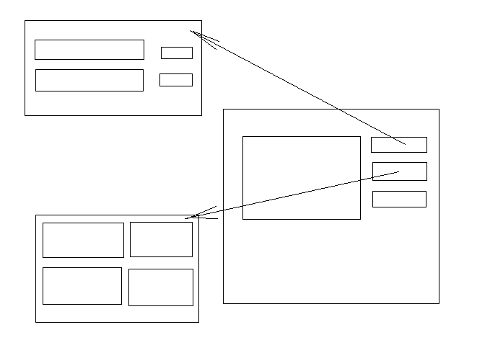…

Source Code
…

1.8 SW Test plan
…

Test scenarios
…

Test Results
…

Bibliography

